DSA0504-Query processing for Data Science Name: Sahasra V
Reg no:192424234

EXPERIMENT-1

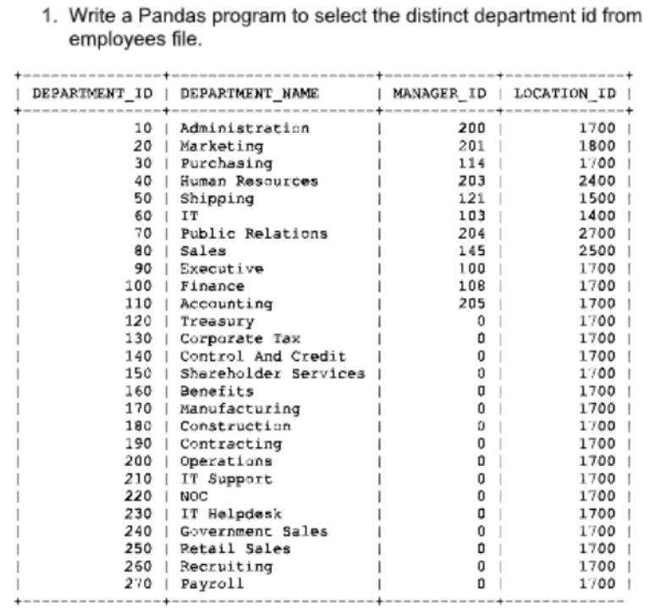

AIM:

To write a Python Pandas program to select and display the distinct Department IDs from the employee department data.

Algorithm:

· Import the pandas library.
· Create the employee department data using a dictionary.
· Convert the dictionary into a Pandas DataFrame.
· Use the drop_duplicates() method on the DEPARTMENT_ID column.
· Display the distinct Department IDs.

CODE:

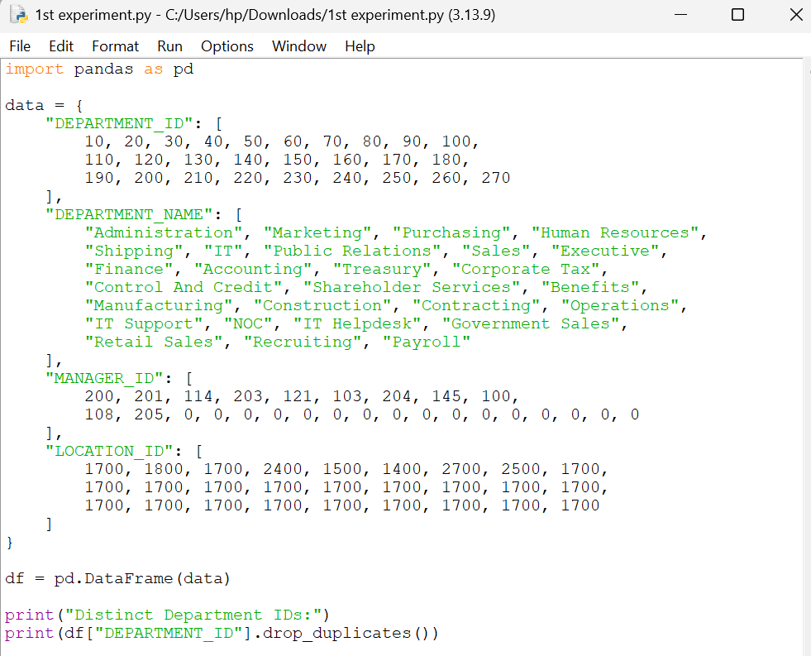

OUTPUT:

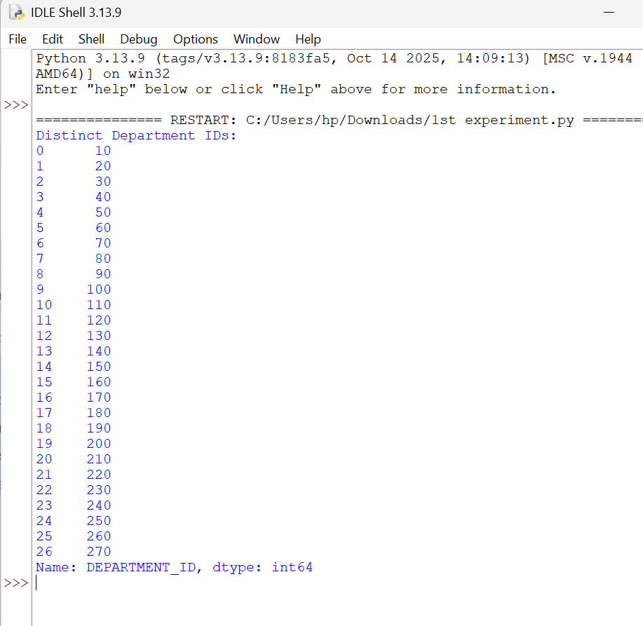\

Result:
The program was executed successfully, and the distinct Department IDs were displayed without any duplicate values.

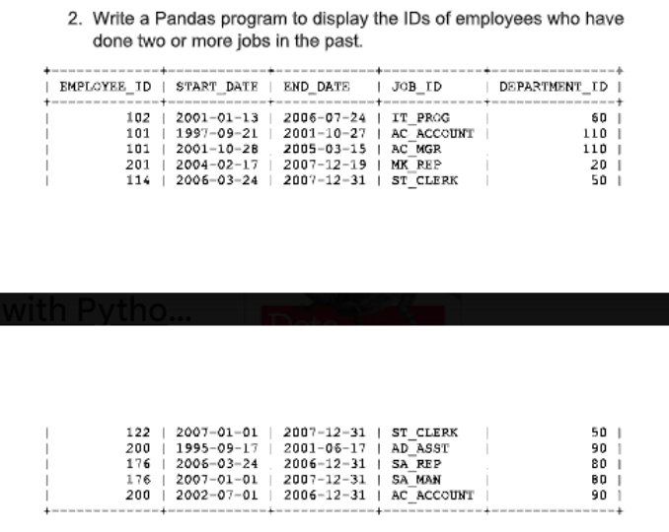

AIM:
To write a pandas program to display the IDs of employees who have done two or more jobs in the past

Algorithm:
- Import the pandas library.
- Create the employee job history data using a dictionary.
- Convert the dictionary into a Pandas DataFrame.
- Count the occurrences of each EMPLOYEE_ID using value_counts().
- Display the Employee IDs whose count is 2 or more.

CODE:
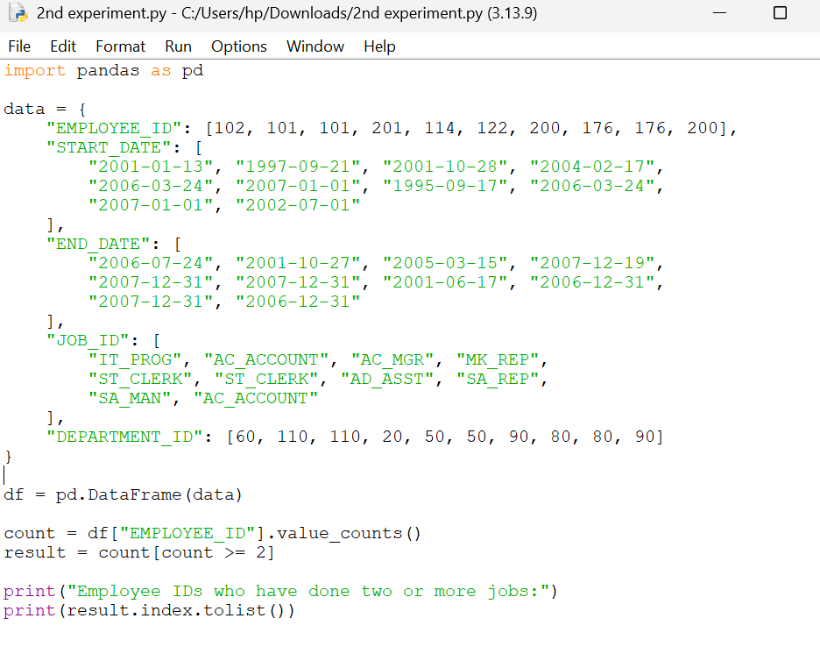

OUTPUT:
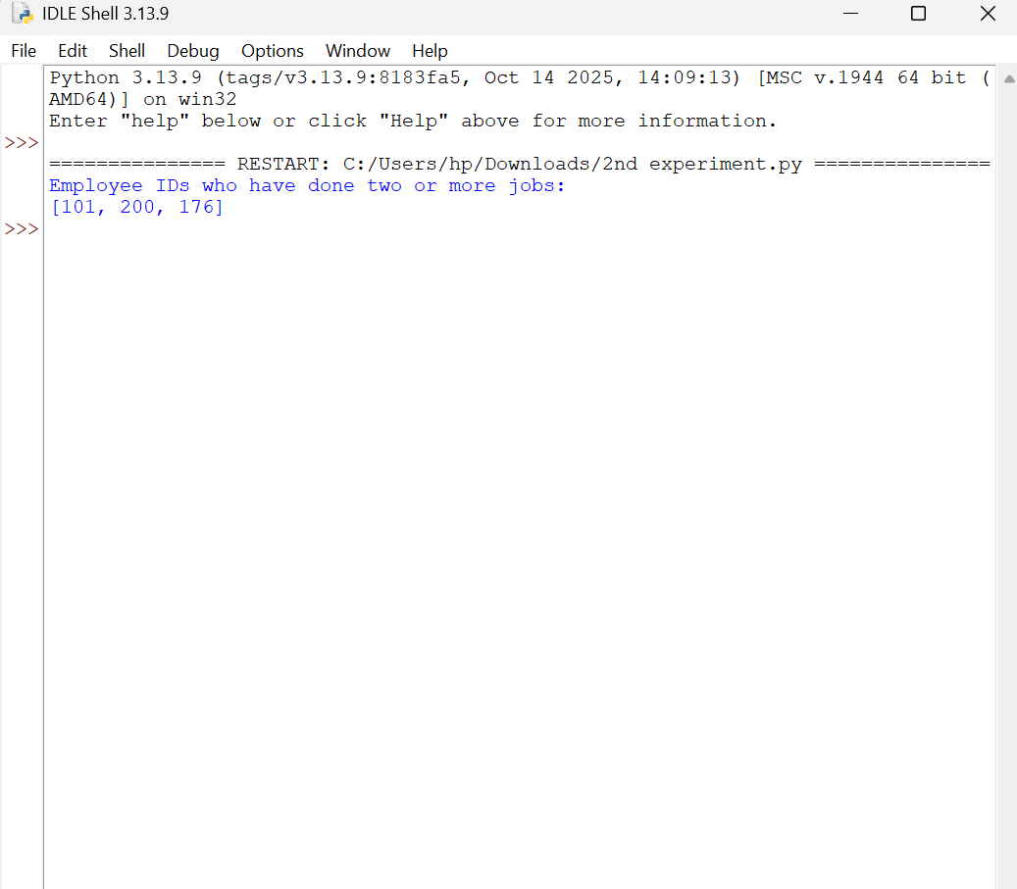

Result:
Thus the program executed successfully to display employee ID who have done two or more jobs in the past

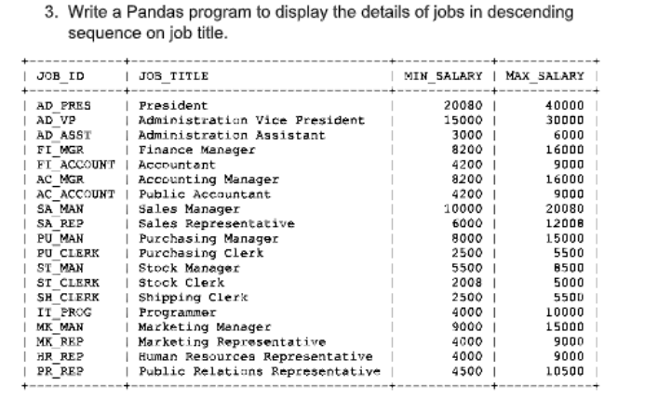

AIM:
To write a pandas program to display the details of jobs in descending sequence on job title

Algorithm:
· Import the pandas library.
· Create the jobs data using a dictionary.
· Convert the dictionary into a Pandas DataFrame.
· Sort the DataFrame by the JOB_TITLE column in descending order.
· Display the sorted job details.

CODE:
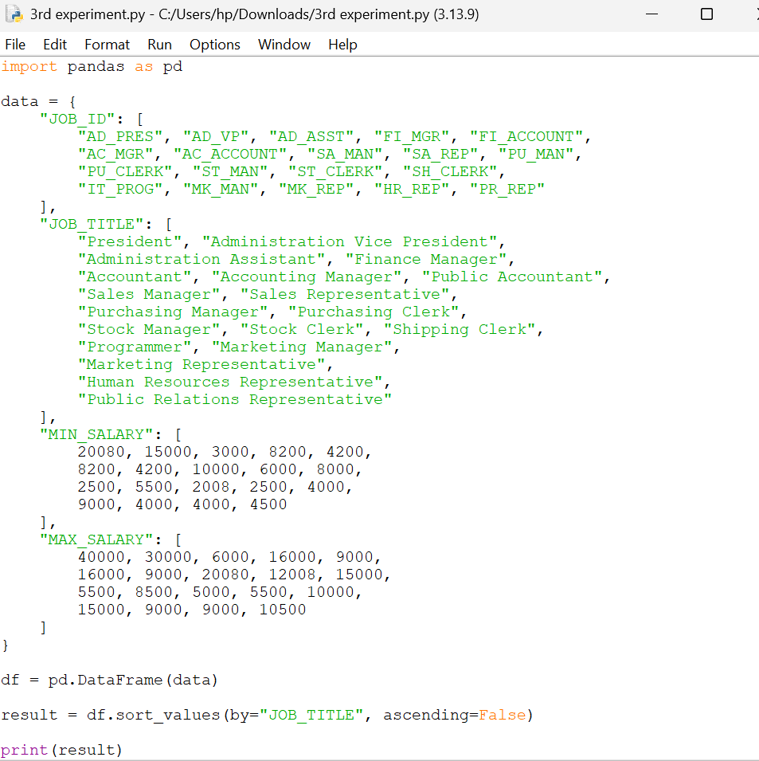

OUTPUT:

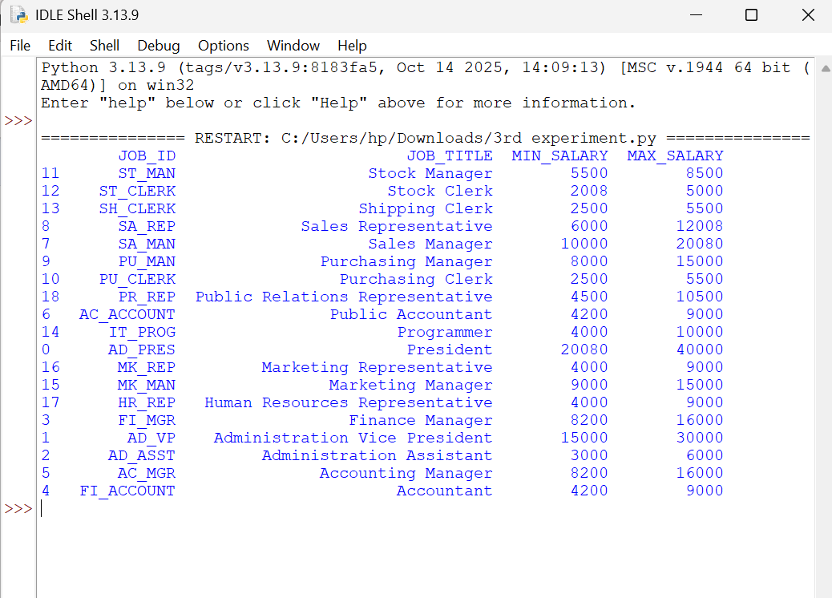

Result:
The program was executed successfully, and the job details were displayed in descending order of the JOB_TITLE column.

4. Write a Pandas program to create a line plot of the historical stock prices of Alphabet Inc. between two specific dates.

Aim
To create a line plot showing the historical stock prices of Alphabet Inc. between two specific dates using Pandas.

Algorithm
- Import the pandas and matplotlib.pyplot libraries.
- Create a DataFrame with stock prices and dates.
- Convert the Date column to datetime format.
- Filter the data between the specified dates.
- Plot a line graph of the stock prices and display it.
CODE:
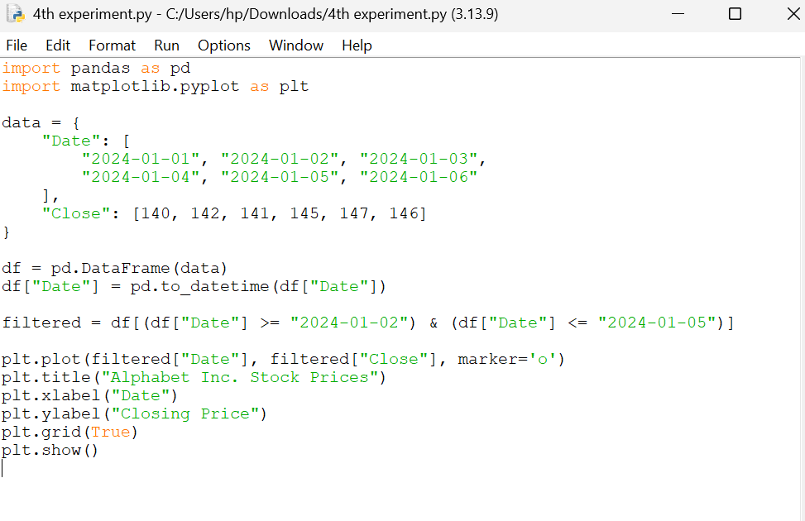
OUTPUT:
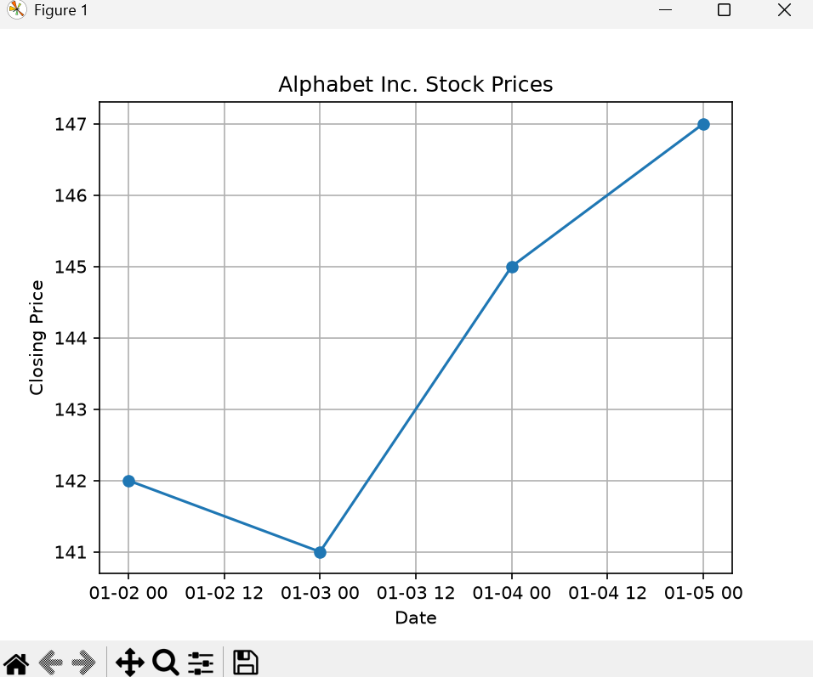

5. Write a Pandas program to create a bar plot of the trading volume of Alphabet Inc. stock between two specific dates.

Aim
To create a bar plot showing the trading volume of Alphabet Inc. stock between two specific dates using Pandas.

Algorithm
- Import the pandas and matplotlib.pyplot libraries.
- Create a DataFrame with trading volume data.
- Convert the Date column to datetime format.
- Filter the data between the specified dates.
- Plot a bar chart of the trading volume and display it.
CODE:
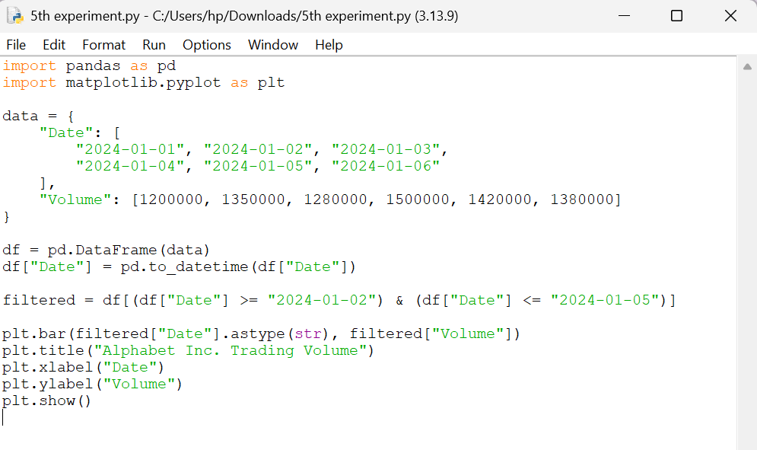
OUTPUT:
